**Meeting Notes**

AASHTO CPBM Organizational Management (OM) Subcommittee and

TRB Workforce Development & Organizational Excellence Committee (AJE15)

December 14, 2020 | 11:00 a.m. - 12:30 p.m. (Central)

**Welcome and Introductions (5 min.) – Deanna Belden, Charlie Purcell and Victoria Beale**

* Others attending – Nigel Blampied, Jack Smith, Alana Spendlove, Charlie Brown, Craig Crick, Jennifer Brown, Gary Vansuch, David Putz, Lori Richter, Lisa Penny, and Stacey Huston.

**FHWA Updates (10 min.) – Jen Brown**

* There are 3 research projects that are being worked on.
  + FHWA edX Pilot Project – highlighted last meeting
  + Leading Indicators
    - The purpose of the project is to identify, analyze, communicate and deploy a set of leading indicators of transportation performance. This set of leading indicators, paired with the Federal TPM measures and other lagging indicators of performance, will provide transportation agencies with a more complete view of the factors driving performance changes for proactive intervention and trends in future performance.
    - Final product will be a *TPM Data Fusion Model and Model Testing Results* document that will include an approach transportation agencies can use to identify, analyze, and select their own leading or lagging indicators.
  + Text Analytics
    - With high volume of new performance reporting and performance-based planning documentation, text analytics and data mining methods offer the potential to efficiently help answer some of these important questions facing FHWA and the industry regarding the practices and impacts of TPM approaches. The purpose of this study is to test the usefulness of text analytics techniques to help provide insight into the application of and effectiveness of TPM and PBPP.
* The Leading Indicators project sounds particularly interesting.

**OM Items (30 min.)**

* Activity Updates
  + Activity 1, Process Improvement – Gary Vansuch
    - One of the agenda items is about Activity 1 (process improvement). The Transportation Lean Forum (TLF) is a centerpiece of Activity 1: [https://www.codot.gov/business/process-improvement/multinational-transportation-lean-forum-tlf](https://gcc02.safelinks.protection.outlook.com/?url=https%3A%2F%2Fwww.codot.gov%2Fbusiness%2Fprocess-improvement%2Fmultinational-transportation-lean-forum-tlf&data=04%7C01%7CStacey.Huston%40iowadot.us%7C56f7ffb368414b907e5d08d8a04f1e08%7Ca1e65fcc32fa4fdd86920cc2eb06676e%7C1%7C0%7C637435608959708884%7CUnknown%7CTWFpbGZsb3d8eyJWIjoiMC4wLjAwMDAiLCJQIjoiV2luMzIiLCJBTiI6Ik1haWwiLCJXVCI6Mn0%3D%7C1000&sdata=DXzB%2BsQwA%2BrNVAM2ZOKEUEe7HMeKG4kzOavvV6%2F9muA%3D&reserved=0)
    - The biggest news is that the next TLF webinar will be held as an official part of the upcoming 100th Annual Meeting of TRB!
    - From the Annual Meeting Program, the details for the TLF session are listed below, and we plan to have a primary Keynote session which will have presentations from the transportation agencies in the states of Arizona, Colorado, Idaho, Nebraska, and Utah; and Highways England. The transportation ministry for the Province of New Brunswick was also planning to present; however, since the Province is not a TRB member, there have been some related difficulties.
  + Activity 2, Non-system performance measures – Deanna Belden
    - Will be developing a Research Syntheses proposal on Program and Project Delivery Measures, used for decision making in DOTs. The due date is February 17, 2021.
    - After holidays will be working on the proposal.
  + Activity 3, Supporting the Agency Capability Building (ACB) Portal – Charlie Purcell
    - Been working on a proposal for research on Implementation Project related to NCHRP research project, Ensuring Essential Capabilities for Future Transportation Agency.
    - Various research proposals have been reviewed at previous quarterly meeting.
    - Asking for feedback on the content of this proposal; Charlie will send follow up email for additional comments.

**AJE15 Items (30 min.) – Victoria Beale**

* Victoria shared the TRB scheduled sessions coming up in January.
* Victoria will need to know how much time we’ll need for the informal Workforce Development and Organizational Excellence Committee agenda.
* Still waiting on the link that will be used for entrance into meeting. More to come.

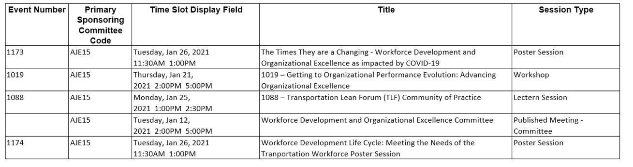

**Wrap-up (5 min.) – Deanna Belden**

* Action items
  + Charlie will resend out the draft implementation research project application with a deadline date for feedback.
  + Victoria will make sure details for joining the January 12th meeting get sent.
  + Charlie and Deanna will work on details for the agenda.
* Upcoming meetings / events
  + Our next joint committee meeting is January 12, 2021, 2:00-5:00 P.M. Eastern Time. This will be held as part of the AJE15 Committee Meeting during the TRB Annual Conference. This will be in lieu of our regular meeting, which would have been on Jan. 19, 2021.